Robust clipped correlation: EURUSD and USDJPY
Method 04 / daily log returns clipped at ±0.01, ±0.02, ±0.03 / Alpari D1 full available history

Study setup
Logical pair: EURUSD , USDJPY
Broker symbols: EURUSD_i , USDJPY_i
Snapshot: 2026-11-03_majors_alpari_D1
Timeframe: D1
Matched return window: 1999-01-05 to 2026-11-02 (UTC bar dates)
Matched return count n: 7200
Dropped unfinished last bar dated 2026-11-03 UTC after a tick-volume check against the prior complete day.
Clip bounds c in log-return units: 0.01, 0.02, 0.03 (about ±1%, ±2%, ±3% on the log scale). Headline c = 0.02.
Clipping caps a day's magnitude at ±c and keeps the row; it does not drop the day, so n is the same at every c.
Complete matched rows (Excel): EURUSD-USDJPY_Clipped_D1.xlsx
Complete matched rows (HTML table): EURUSD-USDJPY_Clipped_D1_data.html

Method carried forward
Each matched daily log return of close, ln(close_t / close_t-1), is clipped in the broker quote direction before Pearson correlation: x_tilde = min(c, max(-c, x)) and y_tilde = min(c, max(-c, y)), then rho_clip = Pearson(x_tilde, y_tilde) on the same rows as raw Pearson r. Quotes are not inverted. A day beyond ±c stays in the sample at the cap; n does not change. rho_clip is symmetric under swap of the two symbols. rho_clip = 0 means no straight-line link among the clipped values in this sample; it does not mean no link of any kind. The score is not a cause, not a lead, and not a trading signal. Daily rows are not independent draws, so the two-sided p-value and Fisher interval are reported and treated as secondary to rho_clip. Cap-hit counts (|log return| > c) flag how much of each leg was capped.

Raw Pearson on the same rows
Pearson r: -0.300952
Two-sided p-value: 1.26181e-150
Approximate 95% Fisher interval: [-0.321814, -0.279798]
This is the unclipped comparison required by the method. The headline score is rho_clip at c = 0.02 below.

Clipped results
n = 7200 at every c. Headline row is c = 0.02. Cap-hit count is the number of days with |log return| > c before clipping.
c | rho_clip | p | ci_low | ci_high | rho_minus_r | EURUSD_cap_hits | USDJPY_cap_hits | EURUSD_cap_share | USDJPY_cap_share
0.01 | -0.345032 | 2.0902323e-200 | -0.36521999 | -0.32451895 | -0.044079437 | 622 | 646 | 0.086389 | 0.089722
0.02 | -0.323102 | 1.3527159e-174 | -0.34363619 | -0.30225854 | -0.022149551 | 41 | 75 | 0.005694 | 0.010417
0.03 | -0.308641 | 1.0319437e-158 | -0.32939179 | -0.28759227 | -0.0076888058 | 4 | 17 | 0.000556 | 0.002361

Conclusion
Over 7200 matched daily log-return rows for EURUSD and USDJPY (broker quote directions unchanged), headline robust clipped correlation at c=0.02 is -0.3231 (negative, weak straight-line association among clipped values in this sample). Approximate 95% Fisher interval on the clipped series: [-0.3436, -0.3023]. Same-sample raw Pearson r is -0.3010 (rho_clip minus r = -0.0221). Sensitivity across the fixed grid: c=0.01 same sign; c=0.02 same sign; c=0.03 same sign. Two-sided p under the usual independent bivariate-normal model is 1.353e-174; that model does not match linked daily FX returns, so treat p as secondary. This does not establish cause, lead-lag, or a lasting trading rule.

What to look at in this file next time
1) rho_clip at c = 0.02 versus raw Pearson r. 2) Whether c = 0.01 and c = 0.03 keep the same sign as 0.02. 3) Cap-hit counts before treating a large gap as settled. 4) The ±0.02 lines on the returns chart and the clip box on the scatter.

Charts
Daily closes

Daily log returns with +/- 0.02 clip lines
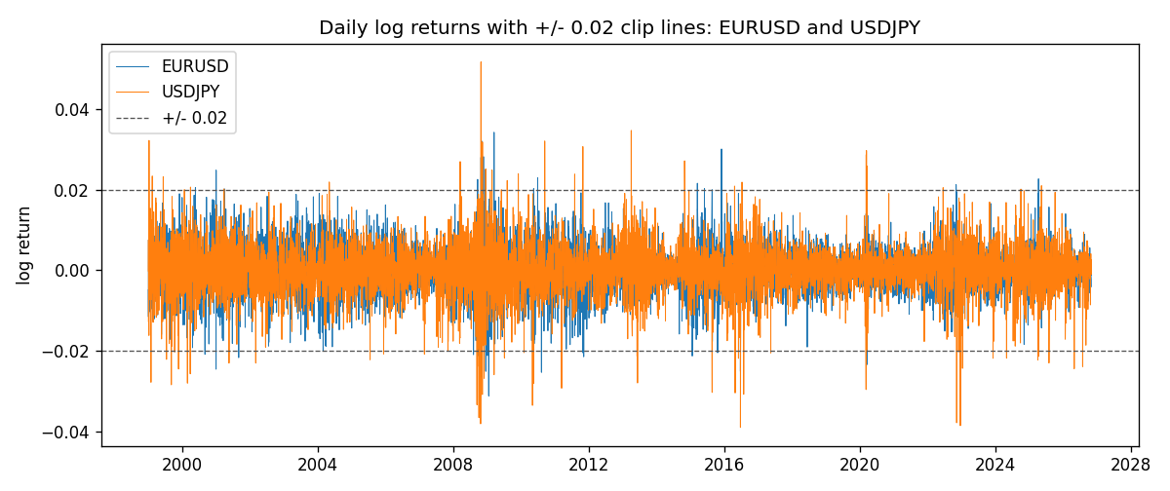
Log-return scatter with +/- 0.02 clip box
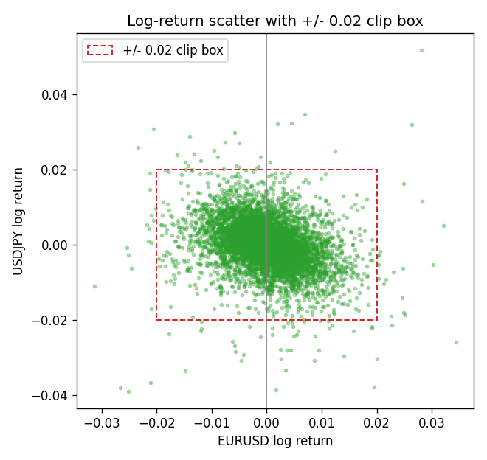

Data report
Every matched row that entered the clipped and raw correlations is stored in the sibling Excel workbook named EURUSD-USDJPY_Clipped_D1.xlsx. That file is the complete data archive for redrawing charts. Embedding all rows as a Word table is impractical at this length; the Word file holds the column list, column summaries, and the first and last 15 matched rows.
Columns: time, EURUSD_open, USDJPY_open, EURUSD_high, USDJPY_high, EURUSD_low, USDJPY_low, EURUSD_close, USDJPY_close, EURUSD_tick_volume, USDJPY_tick_volume, EURUSD_spread, USDJPY_spread, EURUSD_real_volume, USDJPY_real_volume, EURUSD_log_return, USDJPY_log_return, EURUSD_log_return_clip_0p01, USDJPY_log_return_clip_0p01, EURUSD_log_return_clip_0p02, USDJPY_log_return_clip_0p02, EURUSD_log_return_clip_0p03, USDJPY_log_return_clip_0p03
Column summaries (matched calculation rows)
column | count | mean | std | min | 25% | 50% | 75% | max
EURUSD_open | 7200 | 1.1812699 | 0.15089907 | 0.8272 | 1.086045 | 1.16609 | 1.2939325 | 1.5995
USDJPY_open | 7200 | 113.80877 | 19.206548 | 75.693 | 104.4225 | 110.983 | 120.69125 | 163.824
EURUSD_high | 7200 | 1.1864006 | 0.15149686 | 0.8326 | 1.0901575 | 1.17121 | 1.2991625 | 1.6038
USDJPY_high | 7200 | 114.3063 | 19.268128 | 76.001 | 104.878 | 111.441 | 121.26 | 163.978
EURUSD_low | 7200 | 1.1762568 | 0.15022122 | 0.8227 | 1.0819775 | 1.162475 | 1.288265 | 1.5865
USDJPY_low | 7200 | 113.28572 | 19.134551 | 75.402 | 103.8875 | 110.53 | 120.17 | 163.628
EURUSD_close | 7200 | 1.1813075 | 0.15087411 | 0.8267 | 1.085995 | 1.16602 | 1.2939425 | 1.5997
USDJPY_close | 7200 | 113.82186 | 19.221964 | 75.811 | 104.4165 | 111.023 | 120.6855 | 163.851
EURUSD_tick_volume | 7200 | 103020.56 | 173417.03 | 218 | 9398.5 | 52714 | 99443.25 | 1471626
USDJPY_tick_volume | 7200 | 106139.77 | 179306.98 | 149 | 9927.5 | 53095 | 92761 | 1803508
EURUSD_spread | 7200 | 19.389444 | 16.57873 | 0 | 8 | 12 | 30 | 50
USDJPY_spread | 7200 | 20.3175 | 17.636173 | 0 | 6 | 11 | 30 | 50
EURUSD_real_volume | 7200 | 4.0252061e+10 | 1.6676396e+11 | 0 | 0 | 0 | 0 | 3.6149665e+12
USDJPY_real_volume | 7200 | 3.4708591e+10 | 1.6077621e+11 | 0 | 0 | 0 | 0 | 3.8834203e+12
EURUSD_log_return | 7200 | -1.012e-05 | 0.00580063 | -0.03123819 | -0.0032472 | 0 | 0.00325137 | 0.03433183
USDJPY_log_return | 7200 | 4.989e-05 | 0.00620383 | -0.03908203 | -0.00319719 | 0.00011638 | 0.00340925 | 0.05184024
EURUSD_log_return_clip_0p01 | 7200 | -1.261e-05 | 0.00500968 | -0.01 | -0.0032472 | 0 | 0.00325137 | 0.01
USDJPY_log_return_clip_0p01 | 7200 | 9.298e-05 | 0.00508448 | -0.01 | -0.00319719 | 0.00011638 | 0.00340925 | 0.01
EURUSD_log_return_clip_0p02 | 7200 | -1.615e-05 | 0.0057151 | -0.02 | -0.0032472 | 0 | 0.00325137 | 0.02
USDJPY_log_return_clip_0p02 | 7200 | 6.756e-05 | 0.00592919 | -0.02 | -0.00319719 | 0.00011638 | 0.00340925 | 0.02
EURUSD_log_return_clip_0p03 | 7200 | -1.087e-05 | 0.00579466 | -0.03 | -0.0032472 | 0 | 0.00325137 | 0.03
USDJPY_log_return_clip_0p03 | 7200 | 5.215e-05 | 0.00613734 | -0.03 | -0.00319719 | 0.00011638 | 0.00340925 | 0.03
First 15 matched rows (selected columns)
time | EURUSD_close | USDJPY_close | EURUSD_log_return | USDJPY_log_return | EURUSD_log_return_clip_0p02 | USDJPY_log_return_clip_0p02
1999-01-05 | 1.1758 | 111.92 | -0.0048360507 | -0.00017868311 | -0.0048360507 | -0.00017868311
1999-01-06 | 1.1623 | 112.77 | -0.011547966 | 0.0075660159 | -0.011547966 | 0.0075660159
1999-01-07 | 1.1712 | 111.33 | 0.0076280636 | -0.012851583 | 0.0076280636 | -0.012851583
1999-01-08 | 1.1585 | 110.8 | -0.010902799 | -0.0047719894 | -0.010902799 | -0.0047719894
1999-01-11 | 1.1503 | 109.02 | -0.007103287 | -0.016195423 | -0.007103287 | -0.016195423
1999-01-12 | 1.1555 | 112.6 | 0.0045103728 | 0.032310364 | 0.0045103728 | 0.02
1999-01-13 | 1.1681 | 113.52 | 0.010845346 | 0.0081373171 | 0.010845346 | 0.0081373171
1999-01-14 | 1.1681 | 113.52 | 0 | 0 | 0 | 0
1999-01-15 | 1.1563 | 114.15 | -0.010153245 | 0.0055343401 | -0.010153245 | 0.0055343401
1999-01-18 | 1.1605 | 114.16 | 0.0036256946 | 8.7600193e-05 | 0.0036256946 | 8.7600193e-05
1999-01-19 | 1.1603 | 113.52 | -0.00017235436 | -0.0056219403 | -0.00017235436 | -0.0056219403
1999-01-20 | 1.1566 | 112.91 | -0.0031939256 | -0.0053879917 | -0.0031939256 | -0.0053879917
1999-01-21 | 1.1601 | 113.87 | 0.0030215416 | 0.0084664056 | 0.0030215416 | 0.0084664056
1999-01-22 | 1.1587 | 114.56 | -0.0012075213 | 0.0060412564 | -0.0012075213 | 0.0060412564
1999-01-25 | 1.1552 | 113.72 | -0.0030251979 | -0.0073594164 | -0.0030251979 | -0.0073594164
Last 15 matched rows (selected columns)
time | EURUSD_close | USDJPY_close | EURUSD_log_return | USDJPY_log_return | EURUSD_log_return_clip_0p02 | USDJPY_log_return_clip_0p02
2026-10-13 | 1.11965 | 158.305 | 0.0037402957 | -0.0018932826 | 0.0037402957 | -0.0018932826
2026-10-14 | 1.11545 | 158.317 | -0.0037582255 | 7.5800166e-05 | -0.0037582255 | 7.5800166e-05
2026-10-15 | 1.12172 | 158.024 | 0.0056053107 | -0.0018524319 | 0.0056053107 | -0.0018524319
2026-10-16 | 1.12371 | 157.964 | 0.0017724895 | -0.00037976126 | 0.0017724895 | -0.00037976126
2026-10-19 | 1.12086 | 158.517 | -0.0025394633 | 0.0034946841 | -0.0025394633 | 0.0034946841
2026-10-20 | 1.12354 | 158.16 | 0.0023881672 | -0.0022546642 | 0.0023881672 | -0.0022546642
2026-10-21 | 1.12318 | 158.108 | -0.00032046717 | -0.00032883504 | -0.00032046717 | -0.00032883504
2026-10-22 | 1.12139 | 156.755 | -0.0015949606 | -0.0085942669 | -0.0015949606 | -0.0085942669
2026-10-23 | 1.11989 | 156.81 | -0.001338521 | 0.00035080446 | -0.001338521 | 0.00035080446
2026-10-26 | 1.11735 | 157.458 | -0.0022706559 | 0.0041238746 | -0.0022706559 | 0.0041238746
2026-10-27 | 1.11272 | 157.894 | -0.004152342 | 0.0027651658 | -0.004152342 | 0.0027651658
2026-10-28 | 1.1152 | 157.743 | 0.0022262927 | -0.00095679538 | 0.0022262927 | -0.00095679538
2026-10-29 | 1.11772 | 157.683 | 0.0022571351 | -0.00038043789 | 0.0022571351 | -0.00038043789
2026-10-30 | 1.11644 | 157.516 | -0.0011458446 | -0.0010596481 | -0.0011458446 | -0.0010596481
2026-11-02 | 1.11881 | 157.933 | 0.002120569 | 0.0026438521 | 0.002120569 | 0.0026438521

